* **Lab Task 5**

Write a SQL statement that uses a subquery to find those airports located in countries where the official language is 'Arabic'. Return airport name, city, and country code.

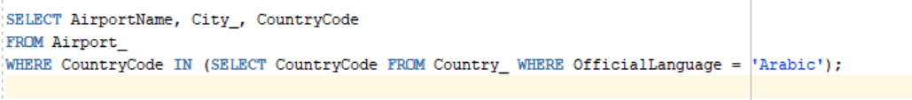

OUTPUT:

